The Data Centre Evolved - Official Opening of the Downtown Montreal Data Centre

Montreal's only true stand-alone, purpose-built data centre
MONTREAL, Sept. 22, 2017 /CNW Telbec/ - Project made possible by a partnership between Urbacon and Fonds immobilier de solidarité FTQ, the new Downtown Montreal Data Centre is officially being opened today. At a cost of over $70 million, this Next Generation Data Centre is located at 544 Rue de l'Inspecteur, in the Griffintown borough, near Montreal's financial district.
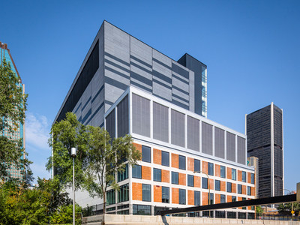
Next Generation Data Centre
The 266,671 SF facility is the only true wholesale and purpose-built data centre in Montreal. The location serves as a global telecom node, providing close proximity to major US cities. Prime connectivity, advantageous climate and favourable hydro rates are other benefits of locating to Quebec.
The facility itself is served by excellent air, rail and road links, has access to a highly-educated ICT staff and has all the features one would expect of a cutting-edge technological facility. With seven dedicated data floors, a total critical power of 30MW, and an annualized mechanical PUE of 1.2 or better, this facility is the data centre evolved. It is Montréal's largest and most secure data centre in its category.
Quotes
"Quebec's colder climate and affordable power has led to a recent boom in data centre development, responding to increased global demands for data storage. With the completion of our new facility, Montreal now has a centralized flagship data centre similar to other major metropolitan centres like Toronto, New York, Los Angeles and Miami. We can now offer a world-class facility that meets the highest standards in terms of structural aspects, security, mechanical and electrical systems for a leading edge data centre." Peter Russell, Vice-President, Properties and Development Management, Urbacon
"By 2020, we expect the data centre sector to grow from 16% to 28%, in particular, because businesses prefer to outsource to data centres rather than incur the heavy cost of setting up such centres in their own facilities. Benefiting from the expertise of the Urbacon team, which has built a solid reputation in this field over the past 30 years, the new Downtown Montreal Data Centre has a distinctive offering, mainly because of its strategic urban location and the superior quality of its facilities." Normand Bélanger, President and CEO, Fonds immobilier de solidarité FTQ
About Urbacon Data Centre Solutions
From vision to unwavering reliability and sustainability, Urbacon Data Centre Solutions Inc. is dedicated to the development, construction and maintenance of data centers and mission-critical facilities. As leaders in developing innovative power and communication systems and resolving mission-critical business continuity and IT infrastructure challenges, Urbacon's expertise and experience is extensive.
Construction Management, Design-Build and Facilities Maintenance are the cornerstones of Urbacon Data Center Solutions Inc. Our clients benefit from leveraging the diverse skill sets of in-house planning, architecture, engineering, construction, project management and real estate expertise. Exceeding client expectations is our number one priority. From construction only assignments to large scale design-build projects and complex facilities that meet exacting environmental criteria — clients engage Urbacon to ensure superior quality, innovation and professional integrity from a single source.
About Fonds immobilier de solidarité FTQ à modifier
Launched in 1991, the Fonds immobilier de solidarité FTQ promotes economic growth and employment in Québec (Canada) by strategically investing in profitable and socially responsible real estate projects in partnership with other industry leaders. The Fonds immobilier backs residential, office, commercial, institutional and industrial projects of all sizes across Québec. At May 31, 2017, the Fonds immobilier had 49 projects with a combined value of $2.9 billion in progress, 45 properties under management, 14 million square feet of land slated for development and $69 million allocated to affordable, social and community housing. The Fonds immobilier is a member of the Canada Green Building Council.
Visit www.fondsimmobilierftq.com

